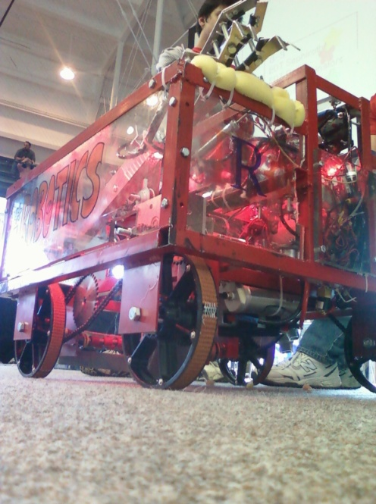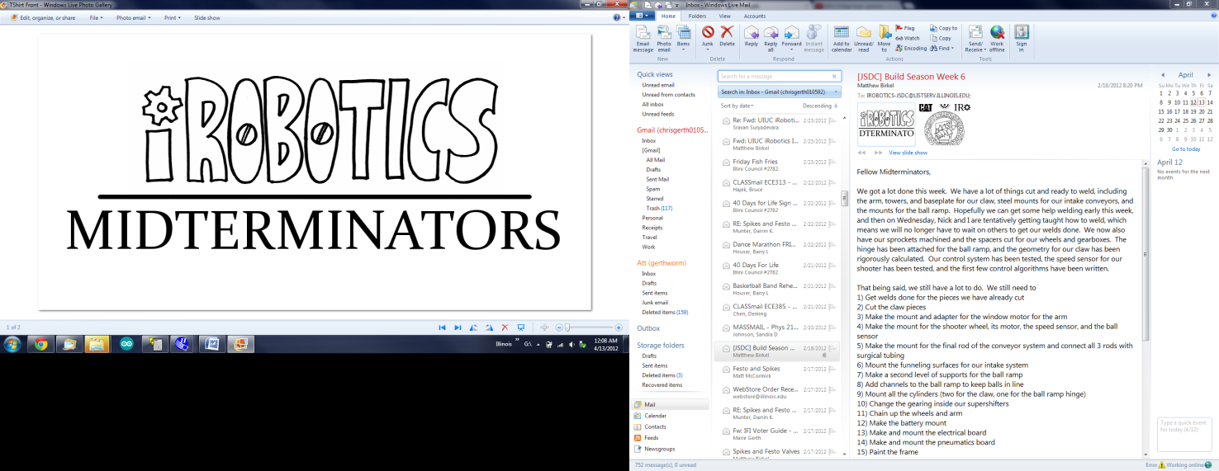

What is iRobotics?

* A club dedicated to educating students about engineering fundamentals through fun, hands-on activities
* A competitor in multiple robotics competitions (Such as the local Jerry Sanders Design Competition during Engineering Open House, as well as the VEX nationals in California)

Like what you see?

* If you want to get involved with our work, contact Matt Birkel at [birkel2@illinois.edu](mailto:birkel2@illinois.edu)
* If you have your own ideas for robotics work, contact the president of the Illinois Robotics Organization, Sravan Suryadevara, at [suryade1@illinois.edu](mailto:suryade1@illinois.edu)



What is iRobotics?

* A club dedicated to educating students about engineering fundamentals through fun, hands-on activities
* A competitor in multiple robotics competitions (Such as the local Jerry Sanders Design Competition during Engineering Open House, as well as the VEX nationals in California)

Like what you see?

* If you want to get involved with our work, contact Matt Birkel at [birkel2@illinois.edu](mailto:birkel2@illinois.edu)
* If you have your own ideas for robotics work, contact the president of the Illinois Robotics Organization, Sravan Suryadevara, at [suryade1@illinois.edu](mailto:suryade1@illinois.edu)